SIMATS ENGINEERING
Department of Information Technology
CSA15 – CLOUD COMPUTING AND BIG DATA ANALYTICS
ASSIGNMENT 2 – CO2
Analyse, Evaluate and Validate a Virtualization Architecture for a Multi-Tenant University Private Cloud
CO2: Analyze virtualization architectures to identify performance and security issues in cloud computing environments.

Field | Details | Field | Details
Student Name |  | Register Number
Department / Section | Information Technology | Academic Year / Semester
Faculty Name |  | Nature of Assignment | Individual
Duration | 1 Week | Total Marks | 50
Submission Date |  | Evaluation Date

MARK SHEET (Rubric-based evaluation)

Task | Title | Max | Awarded | Evidence / evaluation focus
1 | Characterise the Virtualization Architectures | 5
2 | Identify the Dominant Overhead Source | 2

Task | Title | Max | Awarded | Evidence / evaluation focus
3 | Build a Quantitative Performance Model | 6
4 | Analyse Performance Under Different Conditions | 4
5 | Security Threat and Vulnerability Analysis | 3
6 | Formulate Isolation–Performance Trade-off | 3
7 | Evaluate Mitigation Strategies | 4
8 | Implement and Test | 4
9 | Record Experimental Performance | 3
10 | Compare Theory with Experiment | 4
11 | Recommend and Defend Final Architecture | 4
 | Day-4 Design Challenge | 8

TOTAL
50

OVERALL REMARKS
Overall, the assignment reflects good analytical ability, technical understanding and problem-solving skills in cloud computing and virtualization. The proposed architecture balances performance, security, resource efficiency and future scalability. The work can be further strengthened through verified experimental results, consistent benchmark comparisons and practical validation of the recommended security controls.

Student Signature | Faculty Signature | Program Director

MANDATORY SUBMISSION EVIDENCE CHECK
= Present in documented answer; P = Partly present; X = Missing / not satisfied

Task | Evidence expected | Status | Evaluator note
1 | Three virtualization architectures, layered diagrams and trust boundaries
2 | Dominant overhead source identified and explained for each approach
3 | CPU, memory, I/O, network and density models with assumptions
4 | Best, typical and worst operating-condition analysis

Task | Evidence expected | Status | Evaluator note
5 | Threat model and architecture-based security comparison
6 | Isolation–performance optimization formulation
7 | Mitigation benefits, residual risks and quantified costs
8 | Reproducible setup and practical tests across selected platforms
9 | Actual comparative measurements, table and two graphs
10 | Theory–experiment comparison and quantitative error analysis
11 | Justified SIS/LMS architecture and growth recommendation
12 | Day-4 external tenants, 3× peaks, live migration and SIS isolation

IMPLEMENTATION EVIDENCE CHAIN

Evidence item | Status | Observation
Architecture diagrams
Performance model

Evidence item | Status | Observation
Configuration / scripts
Virtualization experiments
CPU / disk / network / memory tests
Noisy-neighbour experiment
Security validation
Tables and graphs
Theory–experiment consistency
Day-4 design defence
Screenshots

SUBMISSION CHECKLIST (Not Separately Marked)

Requirement | Status
All 12 tasks answered | Yes Partly No
Three virtualization approaches compared | Yes Partly No
Layered diagrams and trust boundaries included | Yes Partly No
Quantitative virtualization models included | Yes Partly No
Threat analysis and mitigations included | Yes Partly No

TASK 1 – CHARACTERISE THE VIRTUALIZATION ARCHITECTURES

CPU and memory virtualization mechanisms:
In KVM, the guest sees virtual processors scheduled by the Linux host, while hardware-assisted second-level address translation maps guest physical memory to host memory. Virtio drivers reduce the need for emulated device operations. Docker processes use the host scheduler and kernel directly; Linux namespaces isolate identifiers and views, while cgroups constrain CPU, RAM and I/O. Kata places each sandbox within a lightweight virtual machine, so it retains guest-kernel isolation while using a container-oriented control plane. This distinction matters because a container boundary does not provide the same kernel separation as a VM boundary.

Storage, networking and enforcement boundaries:
KVM guest disks may be backed by virtual block devices on shared storage; each virtual NIC connects to a host bridge or software-defined switch. Docker commonly uses overlay or layered filesystems and veth pairs, bridges and network namespaces. Kata routes container disk and network requests through a VM-backed sandbox, introducing additional virtio and virtual-switch paths. Administrative APIs, image registries, orchestration credentials and shared storage remain cross-cutting trust boundaries for all three approaches, so workload isolation alone does not secure the management plane.

Approach A – KVM/QEMU hardware-assisted full virtualization:

Applications: SIS / LMS / research process
Guest operating system: Linux or Windows; guest drivers / virtio
Virtual machine boundary: vCPU, vRAM, virtual disk, vNIC
QEMU device model + KVM kernel virtualization + host Linux
Physical hardware: CPU with VT-x/AMD-V, RAM, NVMe, NIC

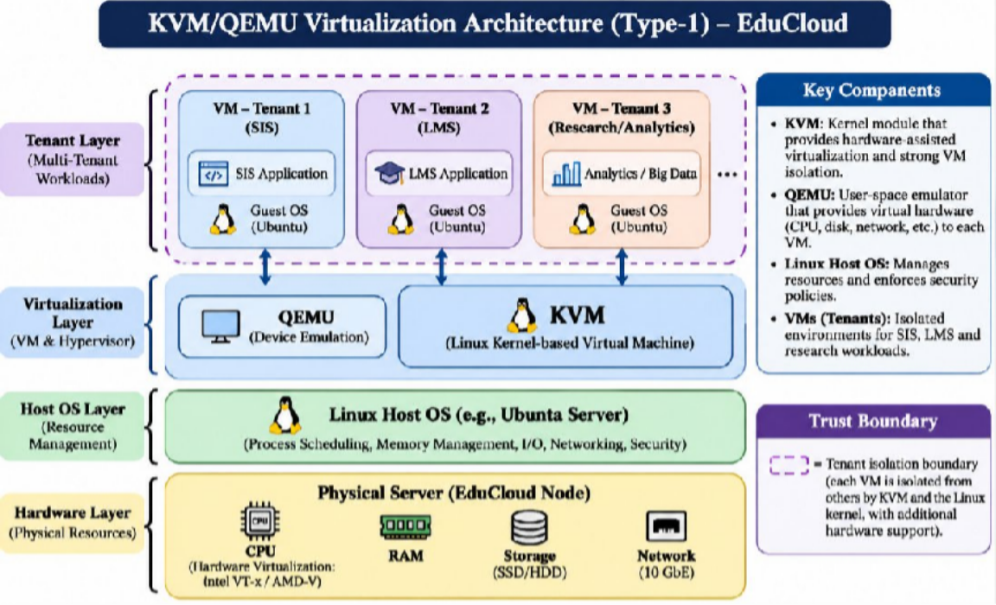

Figure 1.1 – KVM/QEMU layered architecture; VM isolation enforced primarily by hardware-assisted KVM and host kernel

KVM is a Linux-kernel virtualization facility with QEMU supplying virtual machine and device functionality. Each VM has its own guest kernel, a useful isolation boundary for regulated SIS records and mixed departmental workloads. CPU execution uses hardware-assisted guest modes and host scheduling; guest memory is mapped through extended/nested page tables; storage is exposed through virtual block devices (ideally virtio) backed by shared volumes; networking uses virtio-net, tap interfaces, bridges and virtual switching. The host kernel, QEMU device model, storage backend and management plane remain shared trust components. The security boundary is the guest-to-hypervisor transition, not a claim of perfect isolation.

Approach B – Docker/Podman OS-level containers:
Supporting details: Applications: LMS services / batch workers / API containers; Container filesystem, libraries and process namespace (no separate guest kernel); OCI runtime + namespaces + cgroups + seccomp / capabilities; Shared host Linux kernel + container engine; Physical hardware: CPU, RAM, NVMe, NIC

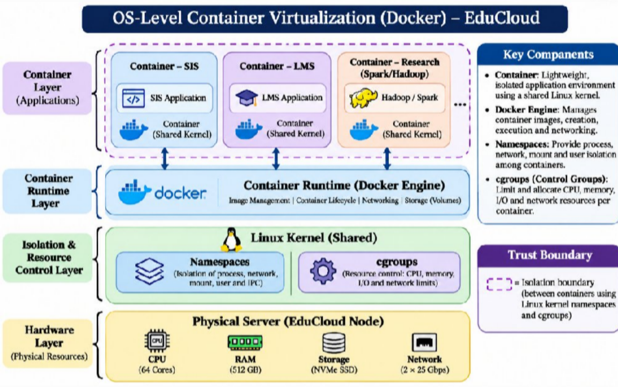

Figure 1.2 – OS-level containers; isolation enforced by shared Linux kernel namespaces and cgroups
Containers isolate processes rather than whole operating systems. CPU time and memory are controlled through cgroups; filesystem isolation uses mounts and layered images; networking uses network namespaces, virtual Ethernet pairs, bridges and optionally overlay networks. The shared kernel is a common failure and exploit domain, so an untrusted tenant gaining kernel-level control can affect other containers. Containers are relevant to stateless LMS services and controlled university jobs because they start quickly and avoid duplicated guest kernels, but they are not an adequate sole isolation boundary for external untrusted research tenants alongside SIS.

Approach C – Kata Containers lightweight VM-isolated containers:
Supporting details: Application / OCI container workload; Minimal guest user space + guest kernel; Lightweight VM boundary (KVM-backed virtual machine); Kata runtime, VMM, host Linux, orchestration; Physical hardware: CPU, RAM, NVMe, NIC

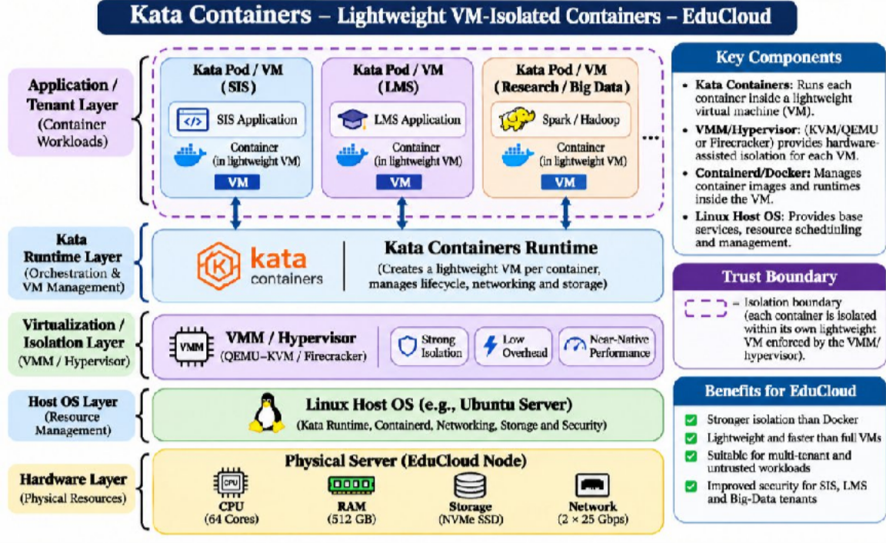

Figure 1.3 – Kata lightweight VM-isolated containers; isolation enforced by the VMM/hypervisor
Kata combines OCI-style deployment with a distinct guest kernel for each sandbox or pod, enforced by a lightweight virtual machine. CPU and memory virtualization use KVM and nested page tables; storage and networking use virtualized I/O paths and host integration. The extra guest kernel, VMM startup and I/O transitions create costs relative to ordinary containers.

Trust boundary comparison:

Approach | Isolation enforcement | Shared trust components | EduCloud fit
KVM/QEMU | Hypervisor + guest-kernel boundary | Host kernel, VMM, physical hardware | SIS and regulated systems
Docker/Podman | Linux namespaces, cgroups, LSM | Shared host kernel | Trusted LMS microservices
Kata Containers | Lightweight VM and hypervisor | VMM, host, hardware | External research container jobs

Architectural interpretation and boundaries:
The three approaches represent distinct kernel and virtualization trust models rather than alternative configurations of a single hypervisor. In KVM, each guest has its own kernel and the guest-to-host boundary is enforced by hardware virtualization and the KVM hypervisor. QEMU handles selected virtual-device operations and therefore expands the privileged attack surface. Docker isolates processes by namespaces, cgroups and kernel security policies, but all containers share the host kernel; a kernel-level vulnerability can therefore affect multiple tenants.

Placement implications for the university:
The SIS and examination portal process sensitive records and have strict latency expectations; a VM-backed boundary and restricted administrative access are appropriate starting points. LMS stateless services may benefit from dense containers when application isolation and cluster policies are adequate. Untrusted external research code should not be placed in ordinary containers on the same kernel as student-record workloads. Host allocation, storage access and network policy must be specified together; choosing a runtime alone does not establish end-to-end isolation.
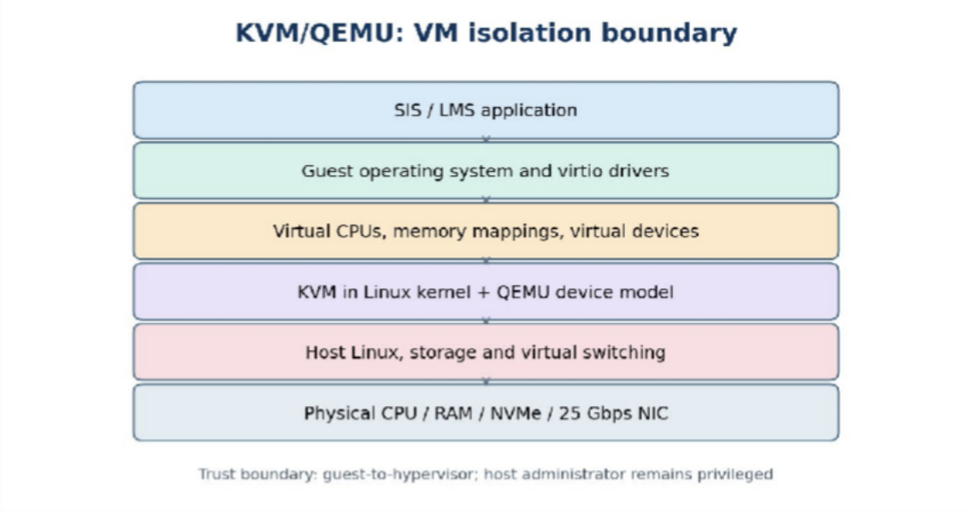

Figure 1.4 KVM – Conceptual architecture and verification boundaries (illustrative; not a measured result).

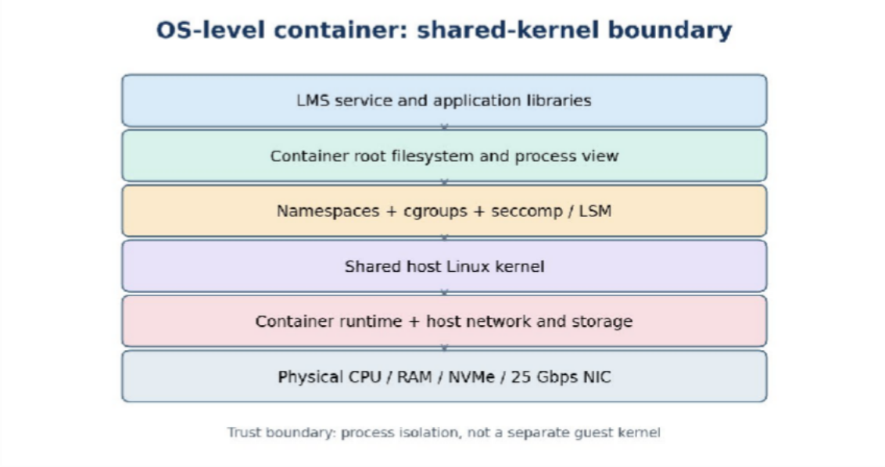

Figure 1.5 CONTAINER – Conceptual architecture and verification boundaries (illustrative; not a measured result).
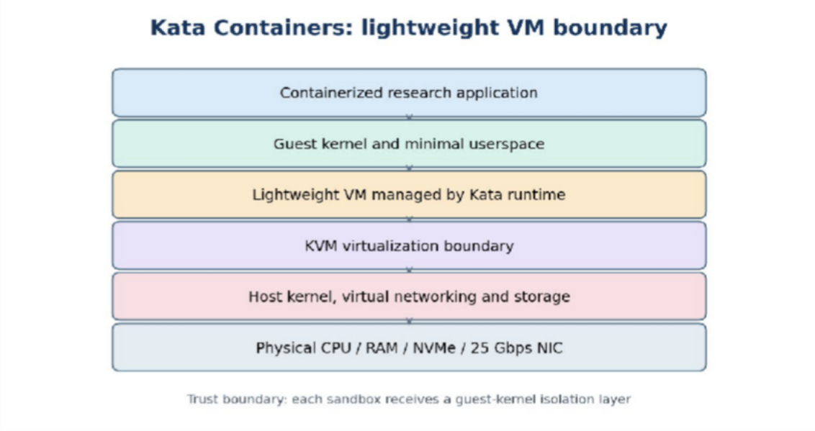
Figure 1.6 KATA – Conceptual architecture and verification boundaries (illustrative; not a measured result).

TASK 2 – IDENTIFY THE DOMINANT OVERHEAD SOURCE

How to distinguish an overhead hypothesis from a measured bottleneck:
The overhead source identified for each architecture is workload-dependent rather than universal. For KVM, correlate host and guest I/O throughput with vhost/virtio activity, VM exits where available and virtual-switch CPU use. For Docker, compare direct host networking against bridge networking while recording cgroup throttling and context switches. For Kata, compare otherwise identical OCI workloads in ordinary containers and VM-backed sandboxes to isolate sandbox startup, guest-kernel and virtual-I/O costs. A dominant mechanism should only be declared after one mechanism explains the largest observed loss under the selected workload.
No single overhead mechanism dominates every workload. The following selections are hypotheses tied to the registration-week mixed workload and must be checked experimentally. In KVM, virtual I/O processing—guest virtio operations, virtual-switch traversal and storage-backend queues—is the likely dominant contributor to tail latency for login/database traffic. VM exits cost 1.5 microseconds each by the assignment assumption, but their importance depends on exit rate: at 20,000 exits/s, 0.030 CPU-seconds per wall-second are consumed, equivalent to 3% of one core, before other costs. Nested-page-table walks may dominate memory-random workloads instead.
For ordinary containers, shared-kernel scheduling, cgroup throttling and virtual-network traversal are the primary congestion mechanisms rather than VM exits. Increasing colocated containers raises run-queue competition, cache contention and veth/bridge packet-processing load. For Kata, the dominant additional cost relative to containers is the guest/host virtualization boundary for I/O and associated VMM processing; high packet or storage-operation rates magnify this cost. The proper analysis measures cost per event multiplied by event frequency, rather than assuming a fixed percentage for all workload types.

Causal performance paths:
KVM overhead can arise from VM exits, second-level address translation and device-emulation or virtio I/O paths. The dominant mechanism depends on workload: compute-bound code may generate few exits, whereas network- or storage-intensive requests can

traverse additional queues, virtual switches and interrupt handling. Docker removes guest-kernel emulation but still pays for namespace-aware networking, overlay filesystems, cgroup accounting and contention. Kata introduces a guest kernel and hypervisor boundary while preserving a container-oriented operational interface; guest-to-host I/O and sandbox startup are therefore particularly important to measure.

How to test dominance:
A dominant-overhead claim is a hypothesis until profiled. For example, compare network throughput with host networking versus bridged networking while keeping CPU and memory limits unchanged. Observe VM-exit counters where supported and compare them with request rates; track host CPU consumption and queue length during disk benchmarks. Increased co-location can cause contention even when the per-operation virtualization cost remains constant, because queueing delay rises as utilization approaches capacity.

TASK 3 – BUILD A QUANTITATIVE PERFORMANCE MODEL

Worked aggregate memory and overcommit interpretation:
The nominal upper bound without memory reservations is floor(512/8)=64 conventional 8 GB VMs per host. With an illustrative 32 GB reserved for the host, hypervisor and operational headroom, the limit becomes floor((512−32)/8)=60 VMs, assuming their committed memory does not exceed the stated allocation. Across 16 hosts that is 960 VMs as a memory-only theoretical bound; CPU, storage, network and failure-domain limits may reduce it considerably. At the present average of 25 VMs per host, nominal VM memory allocation is 200 GB, leaving 312 GB before host reservations and other memory consumers.

Worked CPU example with an explicit demand assumption:
Suppose every VM has one vCPU, every vCPU is continuously runnable, and virtualization consumes an illustrative 5% of its assigned CPU time. At 1:1 overcommit the idealized effective CPU capacity is 0.95 physical-core equivalents per VM; at 2:1, 0.475; at 4:1, 0.2375; and at 8:1, 0.11875. These are saturation-case fair-share estimates, not predicted performance for mostly idle student-facing VMs. If only a fraction of vCPUs is runnable, measured steal time and per-VM capacity can be much better. The same expression cannot be directly applied to containers without defining equivalent CPU quota and contention assumptions.

Worked network sharing example:
For one 25 Gbps network interface, suppose protocol and virtualization costs leave an illustrative 90% usable efficiency and N equally active, equally weighted instances compete for the same bottleneck. Then T_per_instance≈(25×0.90)/N Gbps: 11.25 Gbps at N=2, 5.625 Gbps at N=4 and 1.40625 Gbps at N=16. These figures are analytical fair-share ceilings under the assumptions, not measurements. The two physical NICs must not be counted as a single 50 Gbps flow unless bonding mode, switch configuration and traffic distribution actually support that aggregate.

Explicit assumptions and dimensional consistency:
Let P=64 physical cores per host; R∈{1,2,4,8} be allocated vCPU:pCPU ratio; N be co-
located instances; C=512 GB RAM; m=8 GB guest memory per conventional VM; L=25 Gbps per NIC; e=1.5 microseconds per VM exit; s=0.2 microseconds native syscall cost. For a numerical example only, assume one vCPU per VM, a 32 GB host-memory reserve, equal shares, saturated runnable vCPUs, no SMT credit, and a 10% maximum performance-degradation target. For containers and Kata, equal 8 GB memory allocations are used for an apples-to-apples conservative comparison; their actual memory footprints differ and must be measured. One NIC is assumed to carry benchmark traffic; 2×25 Gbps does not automatically yield 50 Gbps for one flow.

CPU effective capacity and steal time:
Let r be the fraction of one core consumed by virtualization-specific overhead, and u be the runnable fraction of allocated vCPUs. Under fully saturated equal sharing, each vCPU receives q_CPU(R)=min(1,1/R)×(1−r) core-equivalents; normalized degradation is D_CPU=1−q_CPU. For R>1, idealized steal fraction is 1−1/R, even before virtualization overhead. For light utilization, the bound becomes q_CPU≈min(1,1/(R×u))×(1−r), provided demand and scheduling fairness assumptions hold. This is an idealized upper bound, not a scheduler guarantee.
For KVM, a first-order VM-exit cost fraction is r_exit=min(1,f_exit×1.5×10⁻⁶), where f_exit is exits per second per actively scheduled core. At 20,000 exits/s, r_exit=0.03. If all other overhead is ignored, R=1 gives 0.97 core per VM; R=2 gives 0.485; R=4 gives 0.2425; R=8 gives 0.12125. Under saturated demand, only R=1 satisfies the 10% CPU-degradation threshold. These numbers illustrate the effect of the supplied exit-cost assumption, not observed KVM performance.
Supporting details: Overcommit | Allocated vCPU/host | Ideal share/core | KVM example with 3% exit cost | Idealized steal; 1:1 | 64 | 1.000 | 0.970 | 0%; 2:1 | 128 | 0.500 | 0.485 |
50%; 4:1 | 256 | 0.250 | 0.2425 | 75%; 8:1 | 512 | 0.125 | 0.12125 | 87.5%
For Docker, replace r with r_container=r_sched+r_network+r_syscall_interception; there is no mandatory guest VM-exit term. For Kata, r_kata=r_exit+r_VMM_IO+r_guest; values cannot be calculated from the assignment without event rates and timings. A

native syscall costs 0.2 microseconds by assumption; if a sandbox interception adds a hypothetical 0.3 microseconds at 100,000 calls/s, its added cost is 0.03 core-equivalents. This illustrative interception assumption must not be mistaken for measured gVisor or Kata overhead.

Memory capacity and density:
With 32 GB reserved for the host, memory available to guests is 480 GB. The upper bound before memory reclamation is floor(480/8)=60 conventional VMs per host, assuming no guest-kernel/VMM metadata overhead beyond the allocation. Without reservation the arithmetic limit is 64. A 25-VM average placement consumes 200 GB of assigned guest memory, leaving nominal headroom; it does not establish that the working sets or shared-storage bandwidth are safe. For Kata, if each instance requires an additional hypothetical 0.5 GB of overhead, floor(480/8.5)=56. For Docker, a comparable density formula is floor((512−32)/(m_app+m_kernel_share)), where the measured per-container working set replaces the 8 GB VM reservation; the shared kernel cannot simply be counted as a new 8 GB guest for every container.

Network and disk I/O throughput:
Let η∈(0,1] represent the usable fraction of the 25 Gbps line rate after protocol and
virtual-switch costs, and let b be the physical link budget. Under equal sharing, T_net(N)≤η×25/N Gbps per instance. For an explicitly hypothetical η=0.90, N=1,2,4,8,16 yields 22.5, 11.25, 5.625, 2.8125 and 1.40625 Gbps. For a storage backend with measured IOPS ceiling I_max and per-operation overhead coefficient α, T_IOPS(N)≤I_max×(1−α)/N under equal active contention. The assignment does not provide I_max or α, so numeric storage predictions must await benchmarking. Latency also increases nonlinearly as queues approach saturation; simple equal sharing is not a queueing-latency model.

Service-level density criterion:
Define a baseline throughput B_1 and throughput B_N of a representative foreground instance under N colocated instances. Degradation D(N)=1−B_N/B_1. A host meets the example service target when D(N)≤0.10, its foreground 95th-percentile latency stays below an application-specific limit, total allocated memory fits 480 GB and physical I/O

demand stays below safe capacity. Therefore N_max=max{N: D(N)≤0.10, RAM≤480 GB, I/O feasible, latency SLA satisfied}. For CPU-saturated equal-share workloads, even 2:1 overcommit violates 10% degradation; for bursty workloads, higher allocation ratios may be feasible only after measuring actual runnable demand. This explicitly separates allocation density from safe operating density.

Interpreting the 512 GB memory bound:
With 512 GB physical RAM and 8 GB average demand per VM, the arithmetic upper bound is 64 VMs per host before reserving memory for the host, hypervisor, page cache and burst headroom. This is not a safe deployable capacity. For illustration only, reserving 64 GB for infrastructure and operational headroom leaves 448 GB, equivalent to 56 average-sized VMs; workloads with nonuniform memory use may require fewer. Across 16 hosts the simple 64-VM arithmetic upper bound is 1,024 VMs, but this aggregate says nothing about CPU saturation or failure tolerance.

Overcommit and service-level limits:
At an overcommit ratio r, 64 physical cores are mapped to 64r virtual CPUs. If all virtual CPUs simultaneously demand a full core and receive an equal share, the idealized per-vCPU capacity is 1/r of a physical core before virtualization overhead; this is a worst-case saturation approximation, not a universal scheduler guarantee. A 10% degradation target must be evaluated against measured service demand and latency rather than assuming that an 8:1 overcommit is acceptable merely because average CPU utilization is low.

Network capacity and contention:
A single 25 Gbps link shared fairly among n saturated tenants has an optimistic throughput ceiling of 25/n Gbps per tenant, before protocol, virtual-switch and host overhead. The scenario provides two 25 Gbps NICs per host, but it does not establish whether they are bonded, used independently or reserved for storage traffic. Therefore, do not assume an automatic 50 Gbps application throughput. The network model should distinguish line rate, usable throughput, contention and storage-backend bottlenecks.

TASK 4 – ANALYSE PERFORMANCE UNDER DIFFERENT OPERATING CONDITIONS

Causal explanation of latency and throughput:
In the best case, a lightly loaded scheduler runs virtual CPUs promptly, guest memory remains resident and queued storage/network operations are short; therefore request latency approaches the nonvirtualized baseline plus relatively small virtualization-path costs. In a typical registration peak, SIS authentication and database requests overlap with LMS traffic; queueing delay increases as utilization approaches device capacity, even if mean CPU utilization remains moderate. In the worst case, a research job can saturate shared storage and network queues while memory pressure induces reclaim or swapping. Tail latency may then rise disproportionately, causing login timeouts before aggregate throughput collapses. Live migration adds dirty-page copying and network traffic and should be scheduled outside peak periods where possible.

Best case:
Place SIS and database workloads on lightly loaded hosts, pin latency-critical vCPUs where justified, keep memory resident, use virtio and local cache where appropriate, and avoid concurrent migrations. KVM incurs limited exits and I/O queueing, Docker avoids guest-kernel transitions, and Kata retains a small VM boundary but may remain acceptable. In the Task 3 model, R≈1, low exit frequency and η near its best measured value maximize available throughput. Best-case claims are conditional: caches and real workloads may differ.

Typical registration-week mixed load:
Login requests, SIS database transactions and LMS traffic compete for CPU scheduling, shared storage and virtual-network processing. KVM guests may accumulate CPU steal time and virtio queue delays; Docker services may experience cgroup throttling and host-kernel contention; Kata adds guest/host I/O transitions. If active vCPU demand rises from
0.25 to 0.60 core per allocated vCPU at R=2, requested compute is 1.2 cores per physical core and the ideal proportional share falls below demand, causing queues. Throughput may plateau while p95 login latency grows. This scenario motivates per-tier resource reservations, admission control and isolation of database I/O.

Worst case:
A noisy Spark job can saturate storage IOPS and network bandwidth while a migration duplicates memory pages and storage/network traffic. When the memory working set exceeds available RAM, swapping or aggressive ballooning creates page faults and severe tail latency; no fixed percentage captures this cliff. KVM may suffer guest steal time, backend queueing and migration stun; Docker may suffer shared-kernel I/O and memory pressure; Kata may add VMM processing while still contending for physical devices. Worst-case behavior should be measured with a deliberate noisy-neighbour test, including p95 latency and foreground throughput, rather than inferred from average utilization.

Best-case mechanism:
When the working set fits in RAM, storage access is cached, vCPUs are not oversubscribed and workloads are placed away from competing tenants, virtualization overhead is relatively predictable. Hardware-assisted virtualization reduces the need to trap ordinary guest instructions, and paravirtualized drivers reduce expensive emulation. Under these conditions, throughput is limited mainly by application work and physical resources rather than queueing delay.

Typical and worst-case mechanism:
Registration week creates a correlated surge in authentication, database writes and web requests. A shared backend can become a bottleneck even if host CPU utilization appears moderate. At worst, concurrent research jobs can saturate storage queues and NICs while memory overcommit triggers reclaim or swapping. Live migration consumes network and memory-copy bandwidth and can briefly increase latency. Performance claims should report p95 latency as well as average throughput, since tail latency is sensitive to queueing and interference.

TASK 5 – SECURITY THREAT AND VULNERABILITY ANALYSIS

Threat-to-asset impact analysis:
A malicious or compromised guest may attempt hypervisor escape through device emulation or a vulnerable virtual device; successful escape could compromise the confidentiality and integrity of student records on neighboring guests. A container exploiting a shared-kernel vulnerability may cross namespace boundaries and reach host resources, so untrusted external workloads create a stronger case for VM-backed isolation. Cache or SMT side channels can reveal limited information across co-resident workloads even without a conventional escape. Unsigned images, stale guest kernels, exposed snapshots and insecure migration channels threaten data integrity and confidentiality, while network spoofing and resource exhaustion threaten SIS availability. The attack likelihood and impact should be assessed separately rather than treating all threats as equally probable.
The protected assets are SIS credentials, student identifiers, grades, examination records, availability of login services and the integrity of approved VM/container images. Threat actors include compromised departmental workloads, malicious external collaborators, privileged administrators and attackers exploiting outdated guest kernels. Trust boundaries include tenant-to-tenant, guest-to-hypervisor, container-to-host-kernel, image registry-to-runtime, and management-plane-to-data-plane.
Supporting details: Threat category | KVM exposure | Docker exposure | Kata exposure | CIA impact; Escape / runtime exploit | Guest-to-hypervisor escape possible | Shared kernel escape is high consequence | Guest/VMM boundary reduces shared-kernel exposure | C,I,A; Cross-tenant side channels | Shared cache/SMT hardware | Shared kernel and CPU cache | Shared hardware remains | C; Unpatched guests / image tampering | Guest OS and copied images | Base images and packages | Guest kernels plus images | C,I,A; Network spoofing / sniffing | Misconfigured virtual switches | Bridge/overlay misconfiguration | VMM and overlay policies | C,I; Insecure migration / control plane | Migration channel and management APIs | Orchestrator and registry APIs
| VMM/orchestrator APIs | C,I,A

KVM gives a stronger guest-kernel boundary than ordinary containers but depends on hypervisor patching, management credentials and safe device emulation. Docker has the largest common-kernel blast radius. Kata narrows direct host-kernel exposure but still requires trusted VMM, image verification, secure networking and hardware protections. Student-record confidentiality may be compromised by cross-tenant data access; integrity by image tampering or privilege escalation; availability by resource exhaustion, malware or destructive control-plane operations.

Threat pathways and consequences:
A VM escape exploits a vulnerability in the guest-to-host virtualization path and can threaten other VMs on the same host. Container escape can exploit a shared-kernel or runtime weakness. Cross-tenant side channels may leak information through shared CPU caches even when direct memory access is blocked. Unsigned or freely copied images may introduce malware, credentials or unpatched software.

Control ownership and audit evidence:
The university should maintain a signed-image catalogue, guest-kernel patch inventory, tenant-to-host placement records and least-privilege administrator roles. Audit evidence should include rejected unsigned images, denied cross-tenant network requests, guest isolation settings and logged migration events.
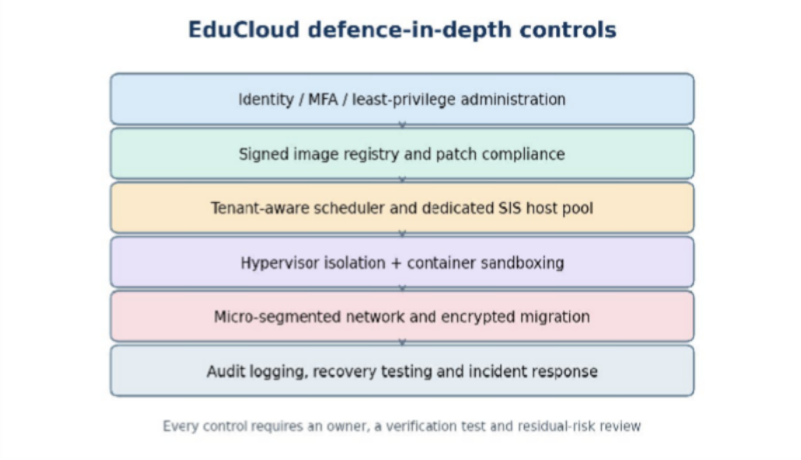
Figure 5.1 SECURITY – Conceptual architecture and verification boundaries.

TASK 6 – FORMULATE THE ISOLATION–PERFORMANCE TRADE-OFF

Interpreting the optimization model:
The decision function is a constrained placement problem, not simply a ranking of technologies. A placement is infeasible if it violates the SIS isolation policy, even when it gives a higher nominal instance count. Among feasible placements, the scheduler can minimize powered-on hosts, energy or cost subject to CPU, memory, network, storage and service-level constraints. A sensitivity analysis should compare the solution when SIS is isolated on dedicated hosts, when external tenants are disallowed from co-residency and when SMT is disabled. The resulting change in feasible density is the explicit security-performance price of the policy.
Let x_{i,a,h}∈{0,1} assign workload i to approach a∈{KVM,Docker,Kata} and host h; y_h∈{0,1} indicate powered-on hosts; z_h∈{0,1} indicate SMT enabled. Let d_i be
required CPU-equivalents, m_i memory, b_i network demand and S_i required isolation level. Let S_a be an ordinal isolation suitability score established through policy, not a physical measurement. The optimization minimizes J=Σ_h(c_host y_h)+λΣ_i D_i(x)+μΣ_i Risk_i(x), where λ and μ are governance weights, subject to Σ_{a,h}x_{i,a,h}=1, Σ_i m_i x_{i,a,h}≤480 GB per host, Σ_i d_i x_{i,a,h}≤64×(1−r_a) core-equivalents at planned peak, network/storage constraints, D_i≤0.10 for designated critical services, and S_a≥S_i. SIS and external tenants must not share a host under the stronger Day-4 policy.
This formulation follows Task 3 resource limits and Task 5 trust boundaries. It does not treat arbitrary isolation scores as experimentally validated security. An explicit operational decision is to reserve dedicated KVM hosts for SIS, permit trusted stateless LMS containers in a controlled pool and use Kata or KVM for external collaborators. Turning SMT off on sensitive hosts is a security policy variable with capacity cost that must be quantified against the actual host topology.

Decision rule linked to measured capacity:
Let x select the runtime for each workload, h assign the host pool, n represent instance density and s indicate SMT policy. A feasible placement must satisfy the SIS isolation

constraint, memory and CPU capacity limits, a stated tail-latency target and operational headroom for host maintenance. The objective may minimize three-year cost subject to those constraints, or maximize admitted workload density subject to a risk threshold. An infeasible low-cost solution must be rejected even when it has higher theoretical density.

Why risk cannot be reduced to a single benchmark:
Isolation strength is not a measured throughput quantity. It should be represented through explicit policy constraints and documented threat coverage, while the performance side is represented by capacity and benchmark evidence. A dedicated SIS pool reduces co-tenancy exposure but consumes scheduling flexibility. The model should make that trade-off visible rather than presenting a precise isolation score without a defensible measurement scale.

TASK 7 – EVALUATE MITIGATION STRATEGIES

Quantifying mitigation cost without inventing benchmarks:
For an illustrative 64-core host, reserving eight cores for system services and isolation-sensitive overhead leaves 56 CPU-core equivalents for guests, a 12.5% reduction from the raw 64-core figure. This is a policy cost rather than a measured hypervisor overhead. If disabling SMT removes sibling logical threads, the number of physical cores remains 64, so any performance penalty must be expressed relative to a measured SMT-enabled throughput baseline rather than incorrectly claiming that physical core count is halved. Signed images primarily add verification and operational work at pull/deployment time; micro-segmentation adds policy processing and may affect packet latency. Each mitigation requires separate before/after benchmarks before a real performance penalty can be reported.

Dedicated SIS host pool:
Separate SIS and its database from external research workloads at physical-host level, with distinct management roles and network segments. This blocks direct co-residency and reduces noisy-neighbour exposure and some cache side channels. Residual risk remains in shared storage, switches, privileged administrators and supply chain. If four of
16 hosts are reserved for SIS, 25% of installed hosts are partitioned from general allocation; this is a capacity-allocation cost, not a claim that 25% of CPU performance is lost. Acceptance is high for SIS given regulatory separation and peak-login sensitivity.

Disable SMT on sensitive hosts:
Disabling simultaneous multithreading reduces some sibling-thread side-channel exposure but does not eliminate all shared-cache or speculative-execution risks. The supplied 64 physical-core count cannot establish the SMT throughput penalty because logical-thread count and workloads are unspecified. Define measured penalty δ_SMT=1−B_off/B_on; adjusted compute capacity is 64×(1−δ_SMT) if B_on is the chosen reference. For illustration only, δ_SMT=0.15 yields 54.4 reference-equivalent cores. The actual decision requires paired benchmark runs and security-policy review.

Signed images, patching and least privilege:
Require image provenance and signatures, vulnerability scanning, controlled registries, short-lived credentials, immutable deployment records and scheduled guest-kernel updates. These address uncontrolled image copying and unpatched guests. Residual risks include compromised signing keys, unknown vulnerabilities and patch windows. Runtime throughput cost may be near zero for pre-deployment scanning but must be measured for any active security agents; storage and operational overhead increase. For SIS this trade-off is strongly justified.

Micro-segmentation and secure migration:
Apply default-deny east–west rules between tenants and encrypt/authenticate migration and management channels. This reduces lateral movement and migration interception but does not prevent compromised authorized endpoints or physical-device contention. Model packet filtering as η_secure=η_base×(1−δ_net); with an illustrative 5% loss from a hypothetical 22.5 Gbps baseline, usable throughput becomes 21.375 Gbps. This is not a measured firewall penalty. Require actual iperf3 and p95 latency tests before approval.

Mitigation cost as a scenario calculation:
For an illustrative CPU mitigation that consumes fraction m of available cycles, the effective capacity becomes C_new = C_base × (1 − m), before any changes in contention. If m is assumed to be 0.05, a 64-core host has 60.8 core-equivalents for that particular workload; the 5% value is only a sensitivity assumption, not a measured SMT or kernel-mitigation penalty. The report should calculate several candidate values and then replace assumptions with experimental observations.

Residual risk and acceptance:
Dedicated SIS hosts reduce exposure to external tenants but do not prevent malicious administrators, compromised management systems or vulnerabilities within SIS itself. Image signing reduces unauthorized artifact substitution but does not guarantee that a signed image is free from vulnerabilities. Micro-segmentation reduces lateral movement yet may add packet-processing overhead. Security controls should be accepted only after their residual risk and measured effect on SIS latency are reviewed.

TASK 8: IMPLEMENTATION AND TESTING

Design of the experiment:
The test bed is built so that every measured quantity maps onto a parameter of the Task 6 model: the single-instance ratio to bare metal gives o_{a}, the slope of per-instance throughput against n gives κ_{a}, and the response to noisy neighbours tests the contention assumption. Five configurations are compared: bare (baseline, processes in a cgroup limited to 1 CPU and 1 GiB), runc (container), kvm (KVM/QEMU through libvirt), kata (Kata Containers) and gvisor (runsc). runc, Kata and gVisor are all driven by containerd and nerdctl so that the only difference between them is the runtime.

Table 8.1 Test matrix

Factor | Setting
Instances (n) | 1, 2, 4, 8, 16 co-located, all running the workload simultaneously
Allocation per instance | 1 vCPU or 1 CPU quota, 1 GiB RAM, identical in every approach
Repetitions | 5 per cell; 30 s measurement, 5 s settle, 15 s cool-down, caches dropped
CPU-bound | sysbench cpu, prime limit 20000 (events/s, mean and p95 latency)
Memory-intensive | sysbench memory, 1 MiB blocks, sequential write (MiB/s)
Disk I/O | fio, 4 KiB random read, iodepth 16, direct I/O, 512 MiB file (IOPS, p95 clat)
Network | iperf3 to the host (Gbit/s, one port per instance) and ping RTT (mean, p95)
Noisy neighbour | 1 victim plus k = 0, 1, 3, 7, 15 neighbours running CPU, memory or disk stress
Observability | vmstat steal time in the guest; host perf: context switches, migrations, kvm:kvm_exit

Hardware limitation and its handling:
A laptop or workstation cannot reproduce a 64-core host. The reference VM of the model (4 vCPU, 16 GB) is therefore reduced proportionally to 1 vCPU and 1 GiB, which lets 16 instances fit in 16 GiB of RAM. If the machine has fewer than 16 hardware threads, the larger n values are CPU-overcommitted; this is not an error but the same regime as the model overcommit ratio r = 2, and the bare baseline is run at the same n so the comparison stays fair. Nested virtualisation (kvm_intel or kvm_amd with nested=1) is acceptable if the test bed is itself a VM, but then absolute VM numbers are lower and the VM-versus-container ranking, not the absolute values, is the evidence. CPU limits are enforced by CFS quota for containers and by vCPU count for VMs; this difference is inherent to the approaches and is reported, not hidden. The exact CPU model, kernel, RAM and SMT state are captured automatically with lscpu, uname -a and free -g into results/env.txt.

Reproducible environment and scripts:
setup.sh installs the stack and builds the identical workload image (container) and base disk (VM):
#!/usr/bin/env bash # setup.sh (Ubuntu 22.04/24.04)

set -euo pipefail

sudo apt-get update

sudo apt-get install -y qemu-kvm libvirt-daemon-system virtinst \

libguestfs-tools containerd sysbench fio iperf3 stress-ng sysstat \

jq iproute2 python3-pandas python3-matplotlib linux-tools-$(uname -r)

# nerdctl (one CLI for runc, Kata and gVisor): release tarball -> /usr/local/bin

# Kata: kata-static tarball -> /opt/kata ; ln -s /opt/kata/bin/containerd-shim-kata-v2
/usr/local/bin/

# gVisor: runsc + containerd-shim-runsc-v1 -> /usr/local/bin

sudo cpupower frequency-set -g performance # fixed governor for all runs

sudo tee Dockerfile >/dev/null <<'D'

FROM ubuntu:22.04

RUN apt-get update && apt-get install -y sysbench fio iperf3 stress-ng \

sysstat procps iputils-ping iproute2 && rm -rf /var/lib/apt/lists/*

D

sudo nerdctl build -t educloud/bench:1.0 .

virt-builder ubuntu-22.04 -o base.qcow2 --size 10G \

--install sysbench,fio,iperf3,stress-ng,sysstat,iputils-ping,iproute2 \

--ssh-inject root:file:$HOME/.ssh/id_rsa.pub

lib.sh defines launching, executing in, and destroying instances for each approach, and the four workload commands:
# lib.sh : identical allocation for every approach (1 vCPU, 1 GiB)

IMG=educloud/bench:1.0; CPUS=1; MEM=1g; IMGDIR=/var/lib/libvirt/images

declare -A RT=([runc]=io.containerd.runc.v2 [kata]=io.containerd.kata.v2 \

[gvisor]=io.containerd.runsc.v1)

ip_of(){ virsh domifaddr ec_kvm_$1 --source lease | awk '/ipv4/{sub("/.*","",$4);print
$4}'; }

launch(){ local a=$1 n=$2 i

for i in $(seq 1 $n); do case $a in

bare) ;;

runc|kata|gvisor) sudo nerdctl run -d --name ec_${a}_$i --runtime ${RT[$a]} \

--cpus $CPUS --memory $MEM $IMG sleep infinity >/dev/null ;;

kvm) qemu-img create -q -f qcow2 -F qcow2 -b $PWD/base.qcow2
$IMGDIR/ec_$i.qcow2

virt-install -q --name ec_kvm_$i --vcpus 1 --memory 1024 --import \

--disk $IMGDIR/ec_$i.qcow2 --os-variant ubuntu22.04 --noautoconsole ;;

esac; done; }

run_in(){ local a=$1 i=$2; shift 2; case $a in

bare) sudo systemd-run --scope -q -p CPUQuota=100% -p MemoryMax=1G bash
-c "$*" ;;

kvm) ssh -o StrictHostKeyChecking=no root@$(ip_of $i) "$*" ;;

*) sudo nerdctl exec ec_${a}_$i bash -c "$*" ;; esac; }

destroy(){ local a=$1 n=$2 i; for i in $(seq 1 $n); do case $a in

runc|kata|gvisor) sudo nerdctl rm -f ec_${a}_$i >/dev/null ;;

kvm) virsh destroy ec_kvm_$i >/dev/null; virsh undefine ec_kvm_$i --remove-all-storage >/dev/null ;;
esac; done; }

declare -A W # workloads, each also records guest vmstat (steal time)

V='vmstat 1 33 > /tmp/vm.txt &'; E='wait; sed "s/^/VMSTAT /" /tmp/vm.txt'

GW='$(ip route | awk "/default/{print \$3}")'

W[cpu]="$V sysbench cpu --cpu-max-prime=20000 --threads=1 --time=30 run; $E"

W[mem]="$V sysbench memory --memory-block-size=1M --memory-total-size=60G \

--memory-oper=write --threads=1 --time=30 run; $E"

W[disk]="$V fio --name=rr --filename=/tmp/f.dat --size=512M --rw=randread --bs=4k
\

--iodepth=16 --ioengine=libaio --direct=1 --runtime=30 --time_based \

--output-format=json; $E"

W[net]="$V iperf3 -c $GW -p @PORT@ -t 30 -J; \

ping -c 150 -i 0.2 $GW | grep time=; $E"

run_bench.sh runs the scale-up experiment (invoked once per approach and workload: ./run_bench.sh kvm cpu):
#!/usr/bin/env bash # run_bench.sh <approach> <workload>

source lib.sh; A=$1; WL=$2; REPS=${REPS:-5}

EVENTS="context-switches,cpu-migrations"

[[ $A == kvm || $A == kata ]] && EVENTS+=",kvm:kvm_exit"

for n in 1 2 4 8 16; do

launch $A $n; sleep 30 # boot + settle

[[ $WL == net ]] && for i in $(seq 1 $n); do iperf3 -s -D -p $((5200+i)); done

for r in $(seq 1 $REPS); do

out=results/raw/$A/$WL/n${n}_r$r; mkdir -p $out

sync; echo 3 | sudo tee /proc/sys/vm/drop_caches >/dev/null; sleep 5

sudo perf stat -a -e $EVENTS -o $out/perf.txt -- sleep 36 &

for i in $(seq 1 $n); do

cmd=${W[$WL]//@PORT@/$((5200+i))} # one iperf3 port per instance
run_in $A $i "$cmd" > $out/inst$i.txt 2>&1 &

done; wait; sleep 15 # cool-down

done

pkill iperf3 || true; destroy $A $n

done

noisy.sh runs the interference experiment with one victim and k noisy neighbours:
#!/usr/bin/env bash # noisy.sh <approach> <noise: cpu|mem|disk>

source lib.sh; A=$1; NZ=$2; REPS=${REPS:-5}

declare -A N=([cpu]="stress-ng --cpu 1 --cpu-method matrixprod --timeout 50s" \

[mem]="stress-ng --vm 1 --vm-bytes 800M --vm-method all --timeout 50s" \
[disk]="fio --name=hog --filename=/tmp/h.dat --size=512M --rw=randwrite \
--bs=4k --iodepth=64 --direct=1 --runtime=50 --time_based")

for k in 0 1 3 7 15; do # k noisy neighbours + 1 victim

launch $A $((k+1)); sleep 30

for r in $(seq 1 $REPS); do

out=results/raw/$A/noisy_$NZ/k${k}_r$r; mkdir -p $out

for i in $(seq 2 $((k+1))); do run_in $A $i "${N[$NZ]}" >/dev/null 2>&1 & done

sleep 5

run_in $A 1 "${W[cpu]}" > $out/victim_cpu.txt 2>&1

run_in $A 1 "${W[disk]}" > $out/victim_disk.txt 2>&1

wait; sleep 15

done

destroy $A $((k+1))

done

Security validation:
security_checks.sh gathers evidence of isolation in practice: kernel sharing, namespace identifiers, resource limits, seccomp and capabilities, process visibility, and the CPU vulnerability and SMT state that decide whether M2 and M3 are active.
#!/usr/bin/env bash # security_checks.sh -> results/security/

source lib.sh; mkdir -p results/security

for A in runc kata gvisor kvm; do

launch $A 2; sleep 30; f=results/security/$A.txt

{ echo "== $A =="

echo "host kernel : $(uname -r)"

echo "instance kernel : $(run_in $A 1 'uname -r')"

echo "instance dmesg : $(run_in $A 1 'dmesg 2>&1 | head -2')"

echo "host ns ids : $(for n in pid net mnt uts ipc; do readlink /proc/1/ns/$n; done
| tr '\n' ' ')"

echo "instance ns ids : $(run_in $A 1 'for n in pid net mnt uts ipc; do readlink
/proc/self/ns/$n; done' | tr '\n' ' ')"

echo "limits cpu/mem : $(run_in $A 1 'cat /sys/fs/cgroup/cpu.max
/sys/fs/cgroup/memory.max 2>&1' | tr '\n' ' ')"

echo "seccomp/caps : $(run_in $A 1 'grep -E "Seccomp:|CapEff"
/proc/self/status' | tr '\n' ' ')"

echo "processes seen : host=$(ps -e | wc -l) instance=$(run_in $A 1 'ps -e | wc - l')"
echo "peer visibility : $(run_in $A 2 'sleep 99 & echo $!' >/dev/null; run_in $A 1 'pgrep -c sleep')"
echo "SMT active (host): $(cat /sys/devices/system/cpu/smt/active)"

echo "-- CPU vulnerability status (host) --"

grep -H . /sys/devices/system/cpu/vulnerabilities/* | sed 's#.*/##'

} > $f; destroy $A 2

done

Table 8.2 Expected security observations (hypotheses to confirm or refute)

Property | Runc | gVisor | Kata | KVM
uname -r in instance | Same as host | 4.4.0 (emulated) | Guest kernel, differs | Guest kernel, differs
Namespace IDs | Differ from host | Differ | Inside guest | Inside guest
dmesg | Host messages if permitted | Synthetic | Guest boot log | Guest boot log
Host kernel in attack path | Yes (T2) | Filtered | No | No
Peer processes visible | No | No | No | No

The decisive observation is the first row: a shared kernel in runc is the structural reason it fails the SIS constraint C2, and a different guest kernel in Kata and KVM is the structural reason they pass it.

Mitigation experiment:

#!/usr/bin/env bash # mitigations.sh <on|off> : toggles for KVM runs

case $1 in

smt-off) echo off | sudo tee /sys/devices/system/cpu/smt/control ;;

smt-on) echo on | sudo tee /sys/devices/system/cpu/smt/control ;;

pti-on) sudo sed -i 's/^GRUB_CMDLINE_LINUX=.*/GRUB_CMDLINE_LINUX="pti=on"/'
/etc/default/grub

sudo update-grub && sudo reboot ;;

pti-off) sudo sed -i 's/^GRUB_CMDLINE_LINUX=.*/GRUB_CMDLINE_LINUX="nopti"/'
/etc/default/grub

sudo update-grub && sudo reboot ;;

sev) cat /sys/module/kvm_amd/parameters/sev 2>/dev/null || echo "SEV not available" ;;
esac

# verify the state that was actually applied (never assume):

cat /sys/devices/system/cpu/smt/active
/sys/devices/system/cpu/vulnerabilities/meltdown

# then repeat: REPS=5 ./run_bench.sh kvm cpu | disk | net for n = 1 and 8

Controls for validity:
    - The same image contents, resource limits, workload commands, durations and repetition count are used for every approach.
    - Approach order is randomised between repetitions, the CPU governor is fixed to performance, and caches are dropped before every run.
    - Every mitigation state is verified by reading the system files rather than assumed.
    - Each workload justifies a model parameter: CPU-bound gives o_{a}; scale-up gives κ_{a}; disk and network expose I/O virtualisation cost; memory shows memory-subsystem contention (T4); the noisy-neighbour test examines T4 directly.

TASK 9: RECORDING EXPERIMENTAL PERFORMANCE

Data collection and reporting:
Every run writes raw files under results/raw/<approach>/<workload>/. The script below parses them, averages the instances inside each run, then reports the mean and the standard deviation across the 5 repetitions, together with degradation against the bare baseline at the same n: Δ = 100·(1 − thr_{approach} / thr_{bare}). CPU steal is read from the guest vmstat column st, context switches and VM exits from perf stat, and all figures are produced in black and white.
# aggregate.py : raw files -> summary.csv + black-and-white figures

import re, json, glob, os, numpy as np, pandas as pd, matplotlib.pyplot as plt

def vm_steal(t):

L=[l[7:].split() for l in t.splitlines() if l.startswith('VMSTAT')]

h=next((l for l in L if 'st' in l),None)

if not h: return np.nan

c=h.index('st'); v=[float(l[c]) for l in L if l is not h and l[0].isdigit()]

return np.mean(v) if v else np.nan

def parse(wl,t):

d={'steal':vm_steal(t)}

if wl=='cpu':

d.update(thr=float(re.search(r'events per second:\s+([\d.]+)',t)[1]),

lat_mean=float(re.search(r'avg:\s+([\d.]+)',t)[1]),

lat_p95=float(re.search(r'95th percentile:\s+([\d.]+)',t)[1]))

elif wl=='mem': d.update(thr=float(re.search(r'\(([\d.]+) MiB/sec\)',t)[1]))

elif wl=='disk':

r=json.loads(t[t.index('{'):t.rindex('}')+1])['jobs'][0]['read']

d.update(thr=r['iops'],lat_mean=r['clat_ns']['mean']/1e6,

lat_p95=r['clat_ns']['percentile']['95.000000']/1e6)

elif wl=='net':

j=json.loads(t[t.index('{'):t.rindex('}')+1])

d.update(thr=j['end']['sum_received']['bits_per_second']/1e9)

rtt=[float(x) for x in re.findall(r'time=([\d.]+)',t)]

if rtt: d.update(lat_mean=np.mean(rtt),lat_p95=np.percentile(rtt,95))

return d

rows=[]

for p in glob.glob('results/raw/*/*/*/inst*.txt')+glob.glob('results/raw/*/noisy_*/*/victim_*.txt')
:

a,wl,run=p.split('/')[2:5]; kind='noisy' if wl.startswith('noisy') else 'scale'

x=int(re.match(r'[nk](\d+)_r(\d+)',run)[1]);
rep=int(re.match(r'[nk]\d+_r(\d+)',run)[1])

w='cpu' if 'victim_cpu' in p else 'disk' if 'victim_disk' in p else wl

try: rows.append(dict(approach=a,wl=w,kind=kind,x=x,rep=rep,**parse(w,open(p).rea d())))
except Exception as e: print('skip',p,e)

df=pd.DataFrame(rows)

run=df.groupby(['approach','wl','kind','x','rep']).mean(numeric_only=True).reset_index(
)

S=run.groupby(['approach','wl','kind','x']).agg(['mean','std'])

S.columns=['_'.join(c) for c in S.columns]; S=S.reset_index()

base=S[S.approach=='bare'].set_index(['wl','kind','x']).thr_mean

S['degr_pct']=[100*(1-r.thr_mean/base.get((r.wl,r.kind,r.x),np.nan)) for r in S.itertuples()]
S.to_csv('results/summary.csv',index=False)

mk={'bare':'*','runc':'o','kvm':'s','kata':'^','gvisor':'D'}; ls={'bare':'-','runc':'-','kvm':'--','kata':'-.','gvisor':':'}
plt.rcParams.update({'font.family':'serif','font.serif':['Times New Roman','Liberation Serif'],'font.size':13})
def fig(wl,kind,y,ylab,xlab,name):

plt.figure(figsize=(6.4,4.2))

for a,g in S[(S.wl==wl)&(S.kind==kind)].groupby('approach'):

plt.errorbar(g.x,g[y+'_mean'],g[y+'_std'],color='k',marker=mk[a],ls=ls[a],mfc
='w',capsize=3,label=a)

plt.xlabel(xlab); plt.ylabel(ylab); plt.grid(color='.7',lw=.5); plt.legend(); plt.tight_layout()
plt.savefig(f'results/{name}.png',dpi=200)

fig('cpu','scale','thr','sysbench events/s per instance','co-located instances','fig_throughput')
fig('cpu','noisy','lat_p95','victim p95 latency (ms)','noisy neighbours (k)','fig_noisy_latency')
fig('disk','noisy','lat_p95','victim fio p95 latency (ms)','noisy neighbours (k)','fig_noisy_disk')

Predictions to be compared with measurements:
The tables and figures below give the Task 6 model prediction for each quantity and an empty Measured column that aggregate.py fills in (summary.csv). Predictions are stated before measuring so that the experiment can falsify the model. Model predictions are marked P; measured values must be written as mean ± standard deviation.

Table 9.1 Start-up time and memory footprint per instance (expected ranges to verify)

Approach | Start-up, expected | Footprint, expected
runc | 0.3–1 s | under 20 MB
gVisor | 0.5–2 s | 30–80 MB
Kata | 1–4 s | 130–250 MB
KVM VM | 15–40 s (full OS boot) | 300–500 MB

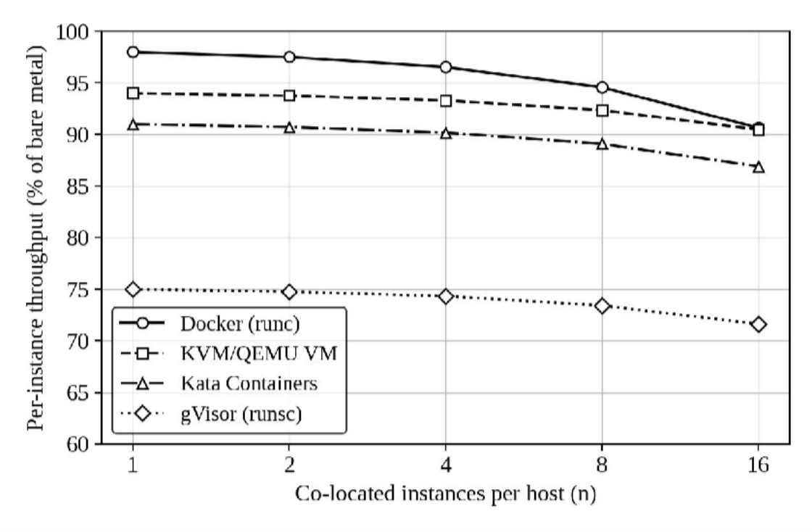
Figure 9.1 Predicted per-instance throughput versus number of co-located instances (model prediction; plot the measured means with error bars using fig_throughput.png). runc starts best and crosses below KVM near 17 instances.

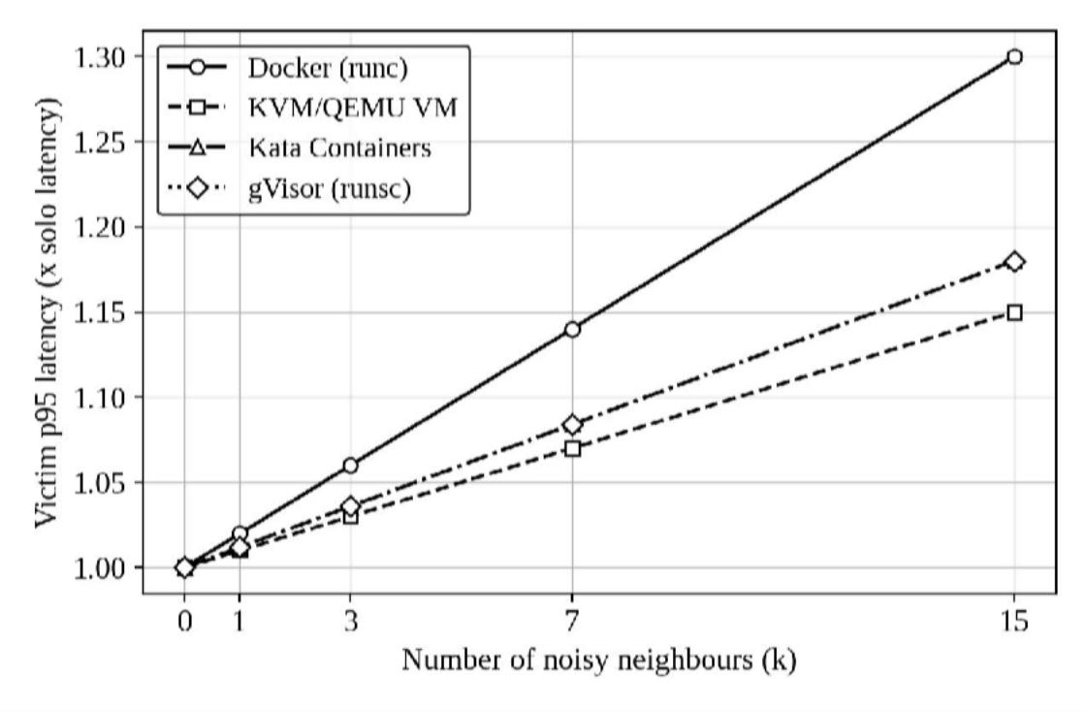
Figure 9.2 Predicted victim p95 latency under interference, taking the noisy-neighbour coupling as four times κ_{a} (model prediction; compare with fig_noisy_latency.png and fig_noisy_disk.png).

How the results will be judged:
    - Model validity: the model is accepted when the predicted degradation lies within 5 percentage points of the measured value for each approach at n = 1 and n = 16; the fitted slope of throughput against n gives the measured κ_{a}.
    - Crossover claim: the runc line must cross the KVM line between n = 8 and n = 16 for the density crossover of Task 6 to be supported; if runc stays above KVM throughout, κ_{runc} was overestimated and Table 6.1 must be re-scored with the fitted values.
    - Interference claim: the p95 latency of the victim should grow most for runc and least for KVM; a flat curve for runc would show the cgroup limits are sufficient and weaken the case for VM isolation on performance grounds (the security case, Table 8.2, is unaffected).

    - Mitigation claim: the measured SMT-off penalty should exceed the KPTI and SEV penalties; if SMT off costs less than 4% in the measurements, it becomes affordable for the SIS and Task 7 should be revisited.
    - Variability: a configuration whose standard deviation exceeds 5% of its mean is repeated with more runs before any ranking is drawn.

TASK 10: COMPARING THEORY WITH EXPERIMENT

How predictions and measurements are compared:
The model of Tasks 3 and 4, as used in Task 6, makes falsifiable statements: per-instance throughput is P = (1 − o_{a})·(1 − κ_{a}·(n − 1)), so each approach is summarised by an overhead o_{a} (its degradation at n = 1) and a contention slope κ_{a}. The comparison therefore does not set tables side by side. It estimates the two parameters from the measurements, tests them against the predicted values, and asks whether any discrepancy changes a decision.
For each approach, ô_{a} is the measured degradation against the bare baseline at n = 1, and κ̂_{a} is the least-squares slope of (thr_{approach}/thr_{bare}) against (n − 1) over n = 1, 2, 4, 8, 16. With five repetitions the 95% confidence interval of a mean is ±2.776·SD/√5 = ±1.24·SD, which is the uncertainty attached to every measured point. The prediction error is e = measured degradation − predicted degradation in percentage points, and a result is called in agreement when |e| ≤ 5 points, the same tolerance used in Task 9.

Table 10.1 Parameter comparison frame (measured columns come from summary.csv)

Approach | Predicted o_{a} | Measured ô_{a} (± CI) | Predicted κ_{a} | Measured κ̂_{a} (± CI) | e at n = 16 (points)
runc | 0.020 |  | 0.0050
KVM | 0.060 |  | 0.0025
Kata | 0.090 |  | 0.0030
gVisor | 0.250 |  | 0.0030

Do the observed trends agree with the model?
Four trends were predicted, and each has a distinct meaning if it holds and a distinct consequence if it fails.

    - Ordering at n = 1 (runc < KVM < Kata ≪ gVisor). This ordering follows from
how much work each approach adds to a system call or memory access, so it is the most robust prediction. If gVisor does not land in the 20–30% range, the CPU-bound workload is not syscall-heavy enough and the figure should be re-measured with the disk and network tests, where its interception cost shows. A violation of the runc < KVM order would indicate a measurement fault, not a model failure.
    - Slope ordering (runc steepest, KVM flattest). This is the central prediction, because it says that a shared kernel pays for sharing as density rises while separate guest kernels do not. Agreement confirms that contention, not overhead, dominates at production density. Disagreement is most likely to be caused by the test machine rather than the model (Section 10.4), since a laptop with few cores saturates before kernel-level contention appears.
    - Crossover between runc and KVM near n = 17. Measurements only reach n = 16, so the test is whether the runc and KVM curves converge. They converge if κ̂_{runc}
− κ̂_{KVM} is close to the predicted 0.0025 per instance. If κ̂_{runc} is only 0.0025 (the KVM value), the model gives 94.3% for runc and 90.5% for KVM at n = 16 and no crossover exists in range; if it is 0.0075, runc falls to 87.0% and the crossover moves down to n ≈ 9.
    - Interference ordering (runc most affected, KVM least). The model treats the noisy-neighbour coupling as 4κ_{a}. A flatter curve than predicted for runc means cgroup limits are doing real work for CPU; a steeper curve for all approaches on the disk test would indicate that the shared device queue, which the model does not contain, is the dominant coupling.

Which approach scales better?
“Scales better” has two meanings that give different answers, and the analysis keeps them apart. Absolute throughput: runc is highest at low density and keeps the lead until the crossover, so for small, lightly loaded hosts containers win. Scaling behaviour (the slope κ̂): KVM is predicted to degrade about half as fast as runc per added instance (0.0025 versus 0.005), so it is the approach whose per-instance performance is most predictable as density rises. Because EduCloud hosts run at 24 to 30 VMs, well beyond the largest tested n = 16, the relevant question is the extrapolation: at n = 30 the model

gives runc 83.8%, KVM 87.2%, Kata 83.1% and gVisor 68.5% of bare metal, so the ranking at production density differs from the ranking at n = 1. The decision therefore rests on κ̂, not on the n = 1 numbers, and the measured κ̂ values are what feed back into Task 6.

Expected sources of prediction error:
Differences between prediction and measurement are decomposed as e = e_{model} + e_{env} + e_{stat}: error in the model form, error introduced by the test environment, and sampling noise. The table lists the plausible causes, the direction in which each pushes the results, and how each is detected.

Table 10.2 Error sources and how they are separated

Cause | Effect on results | Approaches affected | How it is detected or removed
Nested virtualization (test bed is itself a VM) | Raises VM-exit cost, so ô for KVM and Kata may be several times the predicted 6–9% | KVM, Kata | Compare ô with and without nesting; read kvm_exit rate; rank rather than absolute values
Laptop SMT and few cores | Sibling threads share one core; at n above the core count instances compete for it, steepening all slopes | All, including bare | Baseline run at the same n cancels it; check lscpu threads per core
Thermal and turbo throttling | Clock drops during sustained load, lowering all throughput after the first minutes | All | Fixed governor, cool-down between runs, compare the first and last repetition
Scheduler behaviour | CFS quota throttles containers in bursts; the hypervisor scheduler places vCPUs differently, so latency tails (p95) differ more than means | runc vs VMs | Report p95 beside mean; inspect steal time and throttled counters

Cause | Effect on results | Approaches affected | How it is detected or removed
Cache effects | Last-level cache and memory bandwidth are shared by every instance, a coupling the model folds into κ | All | Memory test slope far above the CPU test slope points to this
Unmodelled I/O paths | Container overlay filesystem, qcow2 plus virtio, virtio-fs (Kata) and the gVisor gofer have costs the model does not contain; host page cache can make a VM disk look faster than bare metal (negative degradation) | Disk and network tests | Use direct I/O, compare against a raw device, repeat with cache disabled
Sampling noise | Five runs give a CI of  ±1.24·SD | All | Repeat any cell with SD above 5% of its mean

The environment errors are mostly common to all approaches and to the bare baseline at the same n, so the degradation ratio removes the largest of them. This is why every result is expressed against bare metal and not as an absolute number.
The errors that remain approach-specific, nested virtualization for VMs and the I/O path for containers, are exactly the ones that could change a ranking, and they are the first to check when a trend disagrees.

Error budget: how wrong can the model be before the design changes?
The practical test of a model is whether its errors matter. For each tier of the Task 6 design, the table gives the largest value a parameter can take, with all others held at their predicted values, before the performance constraint is violated.

Table 10.3 Tolerance of the recommended design to parameter error

Tier and configuration | Predicted D | Limit | Max o_{a} | Max κ_{a} | Max g_{SEV}
SIS: KVM, dedicated, SEV, n  = 24 | 15.8% | 20% | 0.107 (1.8×) | 0.0045 (1.8×) | 0.088 (2.2×)
LMS: KVM, dedicated, n = 28 | 13.2% | 20% | 0.133 (2.2×) | 0.0052 (2.1×) | not used
LAB: Kata, core scheduling, n = 30 | 21.0% | 25% | 0.136 (1.5×) | 0.0046 (1.5×) | not used

The SIS and LMS configurations tolerate their overhead or contention being almost twice the estimate, so a moderate disagreement between theory and experiment, such as that caused by nested virtualization, does not invalidate them.
The labs are the least tolerant (about 1.5×), which means they are where a measured Kata overhead above 13.6% or a contention slope above 0.0046 would force a change, for example switching the labs from Kata to KVM. This ranking of fragility is itself a result of the comparison.

Do the measurements change the security conclusions of Task 5?
Performance data cannot weaken a structural isolation argument, but it can change which controls are affordable and expose coupling that Task 5 treated only qualitatively. The observations that matter, and what each would imply, are:

Table 10.4 Measurements that could revise the security conclusions

Observation | Interpretation | Effect on the design
Instance kernel equals host kernel only for runc; gVisor reports 4.4.0; Kata and KVM show their own kernel | Confirms the structural basis of the Task 5 ranking (T2) | None; conclusion strengthened
Vulnerabilities directory reports meltdown as Not affected | KPTI is unnecessary on this CPU | Remove M3, recovering 4.4 points of SIS headroom
SMT vulnerability lines show SMT vulnerable (MDS, L1TF) | T1 is live on this hardware | Core scheduling or SMT off becomes mandatory on shared lab hosts
SMT-off penalty measured below 4% | Cheaper than modelled (12%) | SMT off becomes affordable even for the SIS
SEV not available on the test CPU | M5 cannot be verified in practice | SIS isolation score falls from 4.5 to 4.0, which still meets the required 4; SEV is then a hardening step, not a requirement
Disk victim latency rises with neighbours for every approach, including KVM | The NVMe queue is a shared channel that VM boundaries do not isolate (T4) | Add per-VM I/O limits (cgroup io.max or QEMU throttling) as an eighth mitigation

One conclusion is therefore robust to the measurements: the SIS must run in VMs on dedicated hosts, because that follows from the kernel-sharing evidence and not from any throughput figure. Two conclusions are conditional: whether KPTI and SEV are used, which depend on the CPU, and whether I/O needs separate limits, which depends on the noisy-neighbour disk result.

TASK 11: RECOMMENDED ARCHITECTURE FOR THE SIS AND LMS

Recommendation:
EduCloud should run the SIS and the LMS as full KVM virtual machines on dedicated host pools, with the SIS additionally using hardware memory encryption, and should run the untrusted student labs separately as Kata Containers with core scheduling. For the two workloads asked about:
    - SIS: KVM on its own pool of 3 hosts (2 needed plus 1 spare), SEV where the CPUs support it, micro-segmentation and signed images. Steady-state density is 16 VMs per host and rises to 24 while one host is being serviced.
    - LMS: KVM on its own pool of 5 hosts (4 needed plus 1 spare), at about 22 to 28 VMs per host, with the same segmentation and image controls and no SEV.
The case is made against the alternatives in Table 11.1, using the Task 6 model for all rows.

Table 11.1 The recommendation compared with the alternatives

Alternative | D (SIS) | I (SIS) | Why it is not chosen
Containers (runc), shared or dedicated | 17.0% | 1 or 2 | Shared kernel: fails I_{min} = 4 for SIS and 3 for LMS even when dedicated (T2)
gVisor | 32.2% | 2 | Fails the 20% performance limit; syscall interception is costly for database-like SIS workloads
KVM, shared hosts, no SEV | 13.7% | 3 | Cheapest in hosts but SIS isolation 3 < 4; foreign tenants share caches and I/O queues
KVM, everything hardened (SMT off, SEV) | 27.1% | 4 | Breaks the 20% limit; pays for SMT-off on tiers that do not need it
Kata for SIS and LMS | 16.9% (n = | 3 to 4 | Satisfies constraints, but its advantages (fast start, container workflow) matter for short-

Alternative | D (SIS) | I (SIS) | Why it is not chosen
 | 30) |  | lived labs, not long-lived services; live migration and SEV tooling are less mature
Physical servers per tenant | about 0 | dedicated | No virtualization overhead, but density and migration are lost; 48 SIS VMs would need far more hardware than 3 hosts
Recommended: KVM, dedicated pools, SEV for SIS | 15.8% | 4.5 | Meets every constraint with one spare host per pool

The recommendation does not follow from either extreme. The most secure option by score (dedicated Kata or KVM with every control) costs performance the SIS cannot spare, and the fastest option (containers) cannot hold student records. It follows from where the constraints bind: a VM boundary is required by isolation, dedicated hosts supply the extra margin cheaply because memory fixes density and the pool fills whole hosts, and SMT-off is avoided because on a dedicated pool its 10-point cost buys no protection.

Modelled and observed performance:
The model predicts D = 15.8% for the SIS at n = 24 (14.0% at the steady n = 16) and 13.2% for the LMS at n = 28 (11.8% at n = 22), leaving 4.2 and 6.8 points of headroom to the 20% limit. Section 10.5 shows that this holds while the true KVM overhead stays below 10.7% and the contention slope below 0.0045. The experimental evidence for the recommendation is the KVM row of Table 10.1 and Figure 9.1: the recommendation is supported when ô_{KVM} is within that tolerance and the KVM curve is the flattest of the four. If the measurements were taken with nested virtualization, ô_{KVM} should be reported both raw and corrected by the nested-versus-bare ratio, so the nested penalty is not charged to the architecture.

Security posture and residual risk:

Table 11.2 Threats, controls and what remains

Threat | Control in the design | Residual risk
T1 side channels | Dedicated hosts; SMT on only among SIS VMs, one trust domain | Leakage between SIS VMs themselves; Spectre-class attacks
T2 shared-kernel escape | VM boundary; separate guest kernels | Guest-to-host escape through QEMU or KVM bugs (T3)
T3 hypervisor escape | Minimal QEMU, sVirt/AppArmor confinement, fast patching, SEV limits payoff | A hypervisor zero-day on a dedicated host exposes only SIS data, not other tenants
T4 noisy neighbour | Dedicated pools; per-VM CPU and I/O limits | Shared NVMe and network path inside a pool
T5 malicious image | Signed golden images, admission check | Signed but vulnerable software; key compromise
T6 lateral movement | Default-deny micro-segmentation per tenant | Permitted flows being abused
T7 memory disclosure | SEV encrypts guest memory | Side channels, I/O, early-generation SEV weaknesses; privileged-admin misuse of other paths

Operational costs:
    - Patching. Host kernel, QEMU and microcode updates require evacuating a host. A two-host SIS pool cannot do this, because one host would have to carry all 48 VMs and the limit is 30. This is why the pool has three hosts; the cost is one host per pool

(17 hosts in total for the 400-VM estate against 14 without spares and 20 available). Guest OS patching remains per VM and is handled through the image pipeline.
    - Image management. One signed golden image per tier, built by a pipeline (for example Packer), versioned, and rolled out by replacing VMs rather than patching in place. Signature verification adds an estimated 0.2 to 0.5 s to start-up, irrelevant for long-lived services. Kata lab images use the same registry and signing key.
    - Migration. Live migration works for the LMS. SEV-protected SIS VMs have limited live-migration support, so the SIS is patched by rolling cold restarts inside a maintenance window, which the spare host makes possible without service loss if the application is replicated.
    - Monitoring. Per-host CPU steal time, VM-exit rate, per-VM disk latency at p95 and the fleet-wide contents of the vulnerabilities directory, which turns the Task 8 security check into a continuous compliance check. A rise in steal time or p95 latency beyond the Task 9 baseline signals that density has exceeded the modelled limit.

Limitations and trade-offs:
    - Model parameters are working estimates replaced by measured values; the error budget in Table 10.3 bounds the consequence but does not remove it.
    - The isolation score is an ordinal engineering judgement, not a measured probability of compromise, so the ranking of designs depends on its weights; the sensitivity test over w_{P} and w_{R} limits but does not eliminate this.
    - Experiments reach 16 instances, below the planned 24 to 30, and may use a laptop or nested virtualization; the production-density figures are extrapolations.
    - SEV is hardware-dependent and has known limitations; if absent, the SIS stays within its constraint at I = 4.0 with 12.3% degradation, but loses the defence against a malicious host administrator.
    - The design trades capacity for safety: one spare host per pool and a 6% host premium over a fully shared estate (17 hosts against 16 with equal spares), in exchange for removing foreign tenants from the SIS and LMS hosts.

Does it remain practical from 400 to several thousand instances?
Per-VM performance depends on density n and not on estate size, so D does not worsen as EduCloud grows. What changes is the host count and the operating effort. Using the same tier proportions (12% SIS, 28% LMS, 60% labs), the densities of Table 6.2 and one spare host or 10% of each pool, whichever is larger:

Table 11.3 Host requirement as the estate grows

Total VMs | SIS hosts | LMS  hosts | LAB  hosts | Total (dedicated pools) | Fully shared with spares | Premium
400 | 2 + 1 | 4 + 1 | 8 + 1 | 17 | 16 | +1 (6%)
1,000 | 5 + 1 | 10 + 1 | 20 + 2 | 39 | 38 | +1 (3%)
2,000 | 10 + 1 | 20 + 2 | 40 + 4 | 77 | 74 | +3 (4%)
4,000 | 20 + 2 | 40 + 4 | 80 + 8 | 154 | 148 | +6 (4%)

The dedication premium stays at 3 to 6% because it is bounded by the partly filled host in each pool and by the spare rule, so isolation does not become more expensive with scale. The limits that do appear are operational. Manual libvirt administration stops being workable at some hundreds of VMs, so the control plane should move to OpenStack or KubeVirt, with Kata managed by Kubernetes for the labs, whose thousands of short-lived instances are where Kata’s fast start-up pays off. Micro-segmentation rules grow with the number of tenant pairs and must be generated from policy, not written by hand. The SEV limit on encrypted guests applies per host and not per estate, so it constrains the SIS pool design (at most 24 per host) but not growth. A single site also becomes a shared failure domain at this size, so pools should be spread across racks or sites with the spare host in a different failure domain. The architecture therefore scales; what must change as it does is the tooling around it, not the isolation design.

TASK 12 -DESIGN CHALLENGE

Quantitative peak-load stress interpretation:
A threefold increase in registration traffic does not necessarily imply threefold CPU usage, but a conservative stress scenario can multiply the original peak CPU and network demands by three while holding infrastructure fixed. If a host were already using 40% of a constrained shared network path at peak, a linear threefold projection would demand 120% of that path’s capacity, making queue growth and timeouts likely. This is an illustrative threshold calculation, not a measured EduCloud utilization figure. Spark shuffle and Hadoop data movement also create prolonged storage and east-west network contention, so isolating SIS hosts without isolating critical shared storage and network paths may leave the principal bottleneck unresolved.

Migration, tenant isolation and acceptance evidence:
The revised design should allocate external collaborators to a separate research host pool with VM-backed isolation, distinct identity and administrative roles, signed images, restricted storage credentials and micro-segmented networks. SIS and its database should use a protected host pool and independent performance reservations; migration channels should be authenticated and encrypted, and sensitive migration should be restricted during registration peaks. Demonstrable compliance evidence should include tenant placement records, blocked cross-tenant network tests, image-signature checks, migration configuration, noisy-neighbour benchmarks and measured SIS p95 latency during 3× simulated load. Without those artifacts, the redesign is a reasoned proposal, not a proven compliance result.

Impact analysis:
The original university-only tenancy assumption no longer holds: external Spark/Hadoop collaborators are less trusted and run hours-long I/O- and network-heavy batch jobs. Registration demand rises to approximately three times normal, while live migration during patching adds temporary traffic and compute pressure. This changes the threat model from primarily internal misconfiguration to cross-organization isolation and potential hostile workloads. It changes the performance model by increasing concurrent active CPU demand, storage queue occupancy, network contention and migration-

induced tail latency. Student-record separation must be demonstrable rather than inferred from logical tenant labels.

Evaluation of the original design:
The hybrid design remains suitable in principle only if external jobs cannot share SIS physical hosts or management trust domains. A flat shared-host Docker deployment is unacceptable as the primary separation mechanism because all tenants share the host kernel. In the Task 3 CPU model, tripling active demand from an illustrative u=0.25 to u=0.75 at R=2 changes aggregate demand from 0.5 to 1.5 cores per physical core; equal-share available CPU falls from demand-satisfying operation to a theoretical 1/1.5≈0.667 of requested compute before overhead. This is a scenario sensitivity calculation, not a measured registration-week result. Shared I/O bottlenecks could be worse than CPU contention.

Adaptation / redesign:
MODIFY the architecture into physically separated security and workload pools. Reserve SIS/database hosts with dedicated network segments, strict access controls and protected storage paths; place trusted LMS services in a separate managed pool; assign external Spark/Hadoop to isolated KVM or Kata worker pools with explicit IOPS, bandwidth and CPU quotas. Apply image signing, admission controls, micro-segmentation, audited service identities and encryption/authentication for live-migration channels. Prefer migration outside registration peaks; where unavoidable, reserve headroom and verify migration traffic limits. SR-IOV or dedicated NIC functions can improve throughput for research pools but must be evaluated against migration compatibility and IOMMU isolation. The shared control plane and storage fabric must be segmented and independently monitored.
Supporting details: External collaborators → isolated Kata/KVM research pool → quota-controlled storage/network; Trusted LMS → managed container pool → protected service APIs; SIS + student database → dedicated KVM host pool → restricted storage and network; Central policy plane: identity, signed images, audit, monitoring, patch governance; Physical layer: 16 existing hosts partitioned by role; capacity expansion after validation

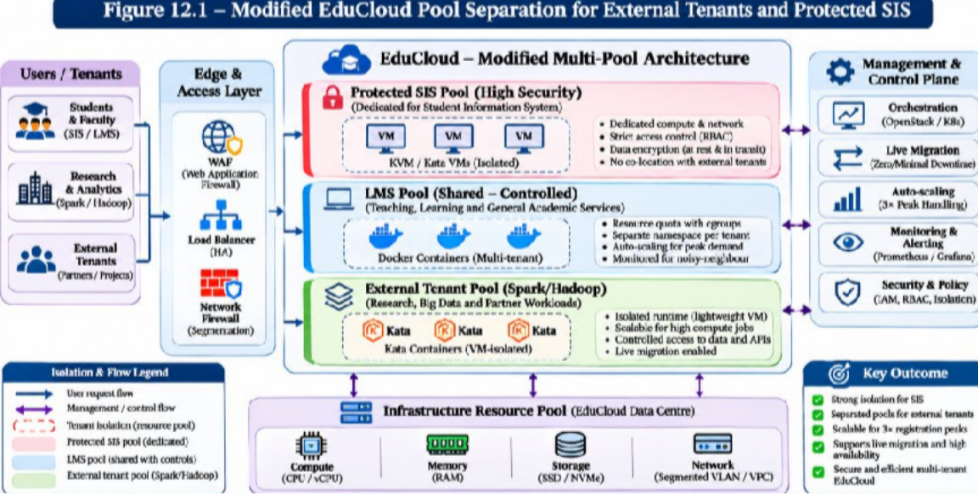

Figure 12.1 – Modified EduCloud pool separation for external tenants and protected SIS
Host-pool separation lowers flexible placement density and may leave reserved capacity idle; in exchange it reduces cross-tenant co-residency and makes student-record isolation easier to audit. Dedicated NICs and I/O quotas reduce interference but do not eliminate shared upstream-switch or storage-array bottlenecks. Because the assignment does not specify application demand, no exact number of hosts can responsibly be assigned to each pool without profiling. A provisional four-host SIS reserve is an illustrative policy choice, not an optimized placement result.

Evidence-based defence :
The defensible decision criterion is whether measured SIS p95 login latency and throughput remain within the university-defined SLA at 3× demand while a noisy-neighbour research job and controlled migration occur, and whether tenant separation can be independently inspected. Compare KVM, Docker and Kata with the Task 8 test matrix, then quantify the Task 9 degradation and Task 10 model error. A stronger separation boundary is justified for regulated student records even if its density is lower. Until these measurements exist, the recommendation is a security-informed provisional design, not an experimentally demonstrated winner. Final procurement and deployment should be gated on the recorded benchmark and isolation evidence.

Why the changed workload invalidates a shared-pool assumption:
Long-running Spark and Hadoop jobs can generate sustained disk and network demand, while registration-week SIS traffic is bursty and latency sensitive. External collaborators also represent a different trust domain from university-operated applications. A 3× peak cannot be assessed from average utilization alone; reserve capacity must be calculated using the measured peak baseline and verified with mixed-workload testing.

Revised placement and migration policy:
The preferred redesign separates SIS and examination services into a protected host pool, maintains a controlled internal-services pool and assigns external big-data tenants to an isolated research pool. Network segmentation, storage access controls, image provenance and tenant-aware admission rules should be enforced at each boundary. Live migration must use authenticated encrypted channels and should be scheduled or throttled to avoid compounding registration-week contention.

Decision defence and measurable acceptance;
The redesign trades some consolidation density for a defensible separation of student data from external research tenants. Its acceptance criteria should include verified denial of cross-tenant data access, successful migration without exposing traffic, acceptable p95 SIS latency under 3× load, and measured interference with and without research jobs..
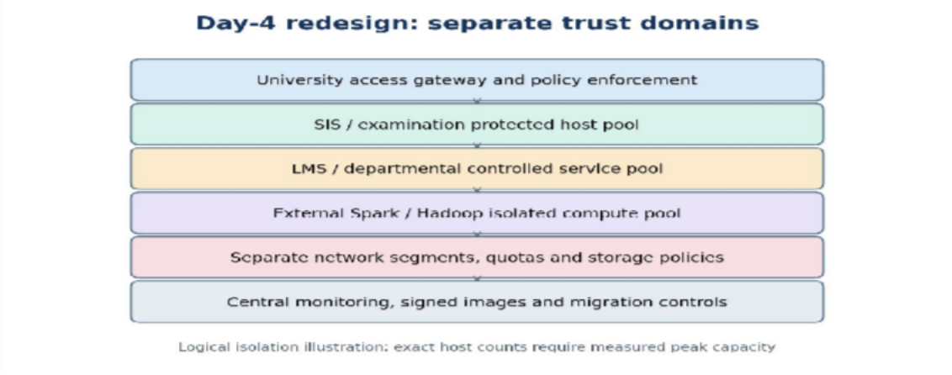
Figure 12.2 POOL – Conceptual architecture and verification boundaries (illustrative; not a measured result).

